Jing Jie Lim

David Albers

**Problem Faced**

Initially we had some hardware issues with the mouse. We had to changed to a specific USB mouse to have it work with the FPGA. Another problem we had was that we wanted to have a RAM that would do the paint function for every pixel on the VGA. We realised that it was not possible as it would take more than 300,000 addresses for it. Instead, we changed the pixel size to be a 4x4 to reduce the number of addresses to about 15,000. The last problem we had was audio. We used the same module from lab 5 but changed it to play a single frequency noise when the mouse buttons are pressed. Unfortunately, calling the module from the top-level module did not create any audio output. We did some testing with signal tap and found that it was working but no audio was being outputted. Finally, we copied the content from part1.sv into the top-level module and the audio worked.

The total hours we spent on this project is 28 hours.

This project was pretty interesting. At first we thought that using the camera module would be very difficult, but the camera driver was already given. We felt that doing a game project would have been more fun as we would have more control on the module we are going to work with.

**Flow Summary:**

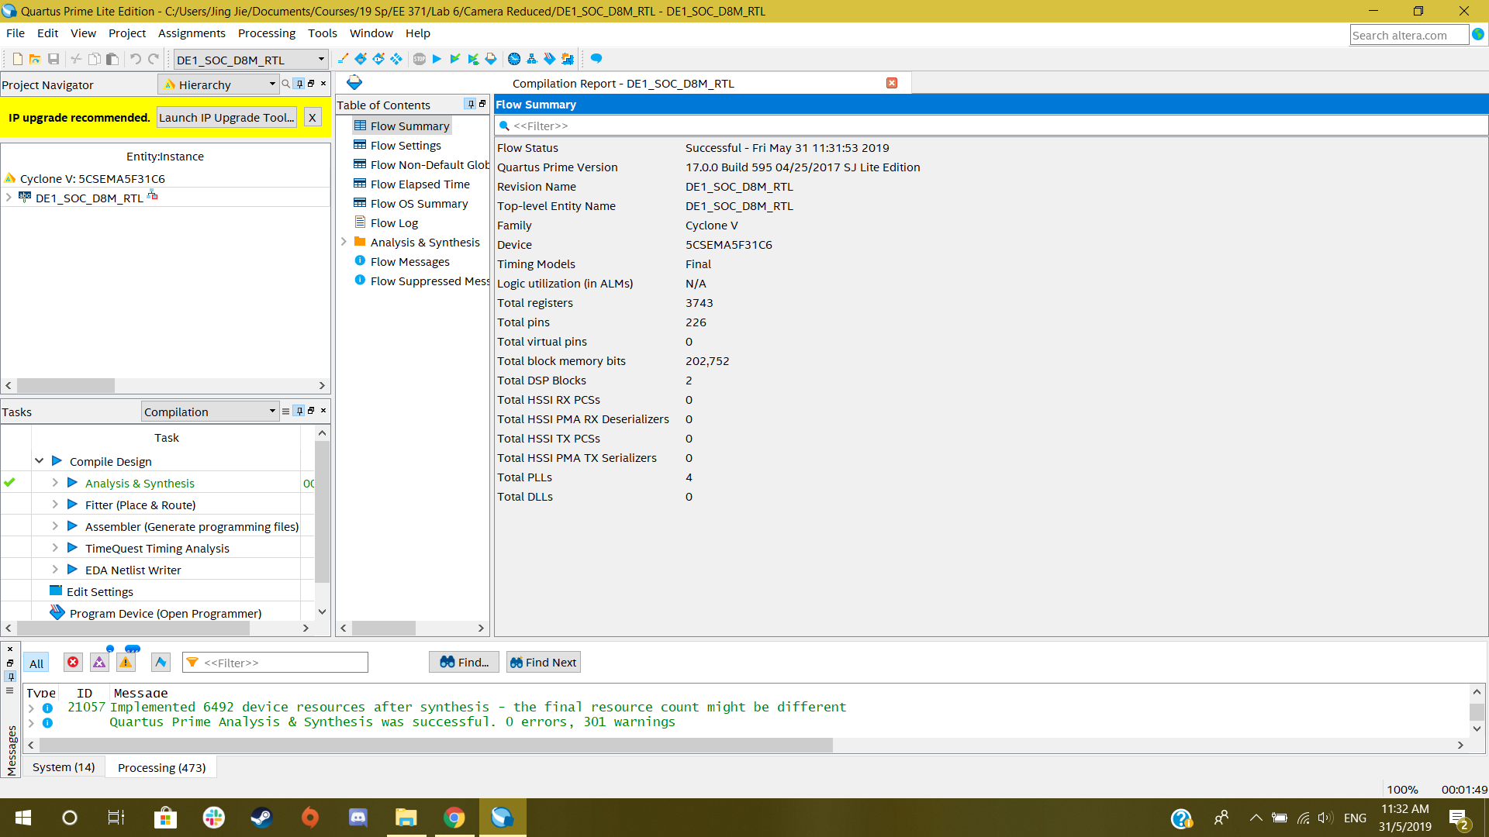

Above is the flow summary from the compilation report of the project.